## 

## Add a Module Structure to your Course

Module structures make it easy for students to find content and provide a consistent student experience across the University.

To add a module structure, choose either the UNH Master Structure 15 weeks of modules or a UNH Master Structure 7 weeks of modules found in Canvas Commons.

1. From the Canvas Global Navigation Menu, click the Commons Button 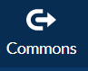
2. In the Search bar, type “UNH Master”, and choose the appropriate module structure.

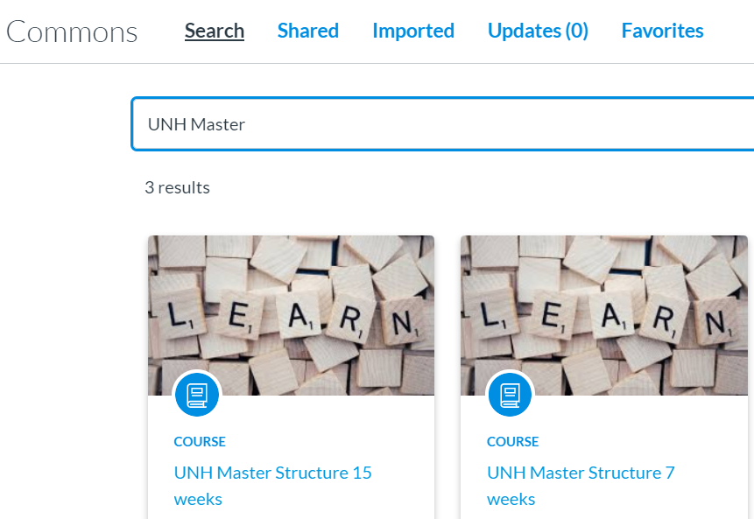

1. You will see a preview of the structure and the Import/Download tool.

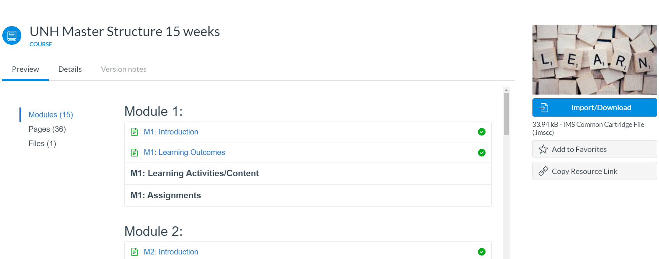

1. Click the Import/Download button to open the Import/Download window and choose the destination course.
2. Click the Import into Course button.

