## 

## **Copy a Canvas Course or Selected Material into an Existing Course**

1. Start in the destination course (ex: your Fall 2020 course).
2. Select "Import Existing Content"

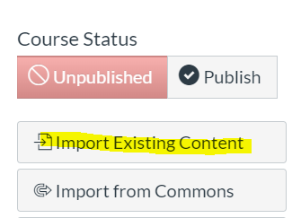

1. Select the content type "Copy a Canvas Course"

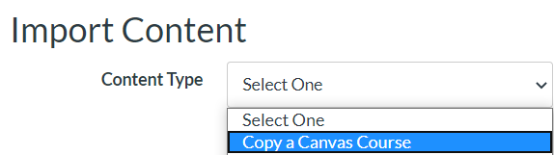

1. Start typing the name of the course of origin (where the material is located) and choose the course from the popup list

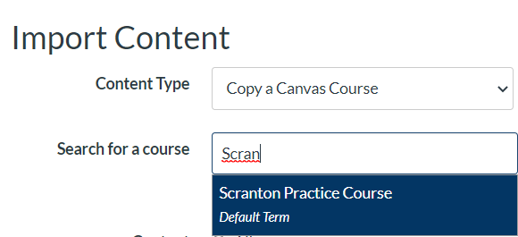

1. Choose “All content” or “Select specific content” – for specific content, click the arrow to expand choices.

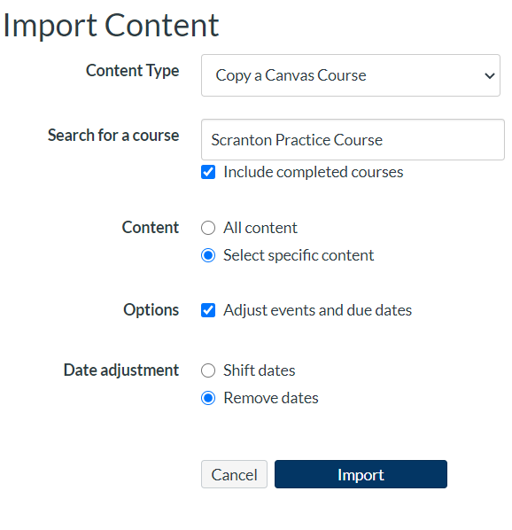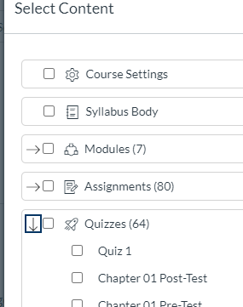

Options - We recommend that you check the “Adjust events and due dates” check box, and then select “Remove dates” from Date adjustment – this will remove all due dates that were copied from the prior term.

1. Click the Import button
2. Wait for import to finish and then check for any "reported issues".
3. Go back to Settings and click the Link Validation Tool to check for broken links.

Remember to **Publish** the course when you are ready for students to access the course.