University of New Haven

Center for Learning Resources

Biology Tutors

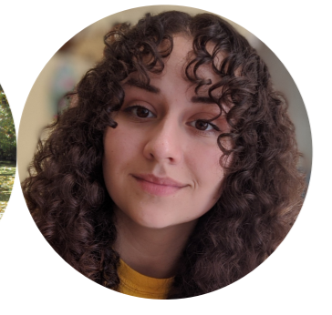

**Nicole Miklinski (She/Her/Hers)**

I’m a junior majoring in Forensic Biology and minoring in Chemistry. I am an undergraduate Forensic Science peer tutor as well as Biology and Math. I am also a General Chemistry Learning Assistant. My hobbies include watching and discussing true crime documentaries, reading Stephen King novels, and playing with my cats.

**Tutors:** BIOL-2253, BIOL-2254, BIOL-3306, BIOL-4591, CHEM-1115, CHEM-1117, CHEM-1118, CHEM-2203, CHEM-2204, COMM-1130, ENGL-0100, FORS-2216, FORS-2217, HIST-1121, HNRS-1112, MATH-2228, PSYC-1111, SPAN-1101, UNIV-1141.

**Link:** <http://newhaven.campus.eab.com/pal/8iSJgBbqmq>

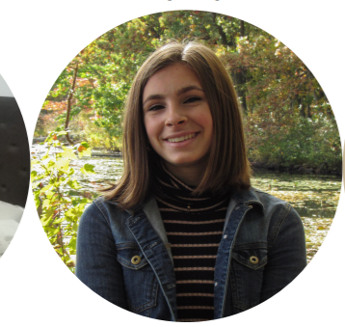

**Mackenzie Pavlik (She/Her/Hers)**

I am a sophomore majoring in Forensic Science with a concentration in chemistry. I will be tutoring forensic science, chemistry, biology, and math! I am also a part of the gymnastics club.

**Tutors:** BIOL-2253, BIOL-2253, BIOL-2254, CHEM-1115, CHEM-1116, CHEM-1117,CHEM-1118, CHEM-2201, CHEM-2202, CHEM-2203, CHEM-2204, CJST-1100, FORS-2216, FORS-2217, HNRS-1112, MATH-1117, MATH-1118, MATH-2203, MATH-2228, PHYS-1103, UNIV-1141

**Link:** <http://newhaven.campus.eab.com/pal/Olf3efsaw8>

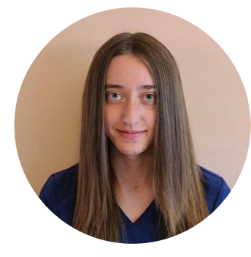

**Hannah Rose (She/Her/Hers)**

I am a senior marine biology student with a minor in biology. My tutoring specialty is marine biology. I have interned at the Philadelphia Zoo as an animal behavior and environmental education intern, and at Mercer County Wildlife Center. I also have worked as a volunteer veterinary technician and plan to attend veterinary school. My outside interests include walking my dog, reading, and going to the beach.

**Tutors:** BIOL-2250, MARN-1101, MARN-1102, MARN-2200, MARN-2260, MARN-3310, MARN-3331, MARN-3900, MARN-4440

**Link:** <http://newhaven.campus.eab.com/pal/tCzx6F-_oo>

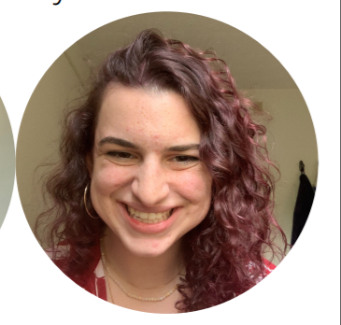

**Rayna Kruzona (She/Her/Hers)**

Hello! My name is Rayna and I am a Forensic Science major with a concentration in Biology. I am a third-year student at the University of New Haven, and I tutor forensic sciences and biology. I play rugby, have houseplants, and enjoy painting!

**Tutors:** BIOL-2253, BIOL-2254, BIOL-2256, BIOL-3393, CHEM-1115, CHEM-1117, CHEM-1118, CHEM-2203, COMM-1130, ENGL-1112, FORS-2216 FORS-2217, FORS-3402, HIST-1101, MATH-1117, PHIL-2222, PHYS-1150, PHYS-1151, PHYS-2205, PHYS-2206, SPAN-1101

**Link:** <http://newhaven.campus.eab.com/pal/hbvOFou_K7>

**Hailey Ortiz Rivera (She/Her/Hers)**

Hello! I am the dental hygiene peer tutor and I’m a junior in the program. I’m also one of the ambassadors for the Dental Hygiene program. I love to learn about teeth, and anything related to oral health. Outside of my major, I enjoy drawing, playing video games, and spending time with my family and friends.

**Tutors:** CHEM-1105, CHEM-1106, DHYG-1110, SOCI-1113, BIOL-1121, BIOL-1123, DIET-1160, DIET-1175, HLTH-2200, DHYG-2215, DHYG-2216, HLTH-2230, DHYG-2240, DHYG-2241, BIOL-2259, BIOL-2260, BIOL-2261, BIOL-2262, BIOL-2263, DHYG-3327

**Link:** <https://newhaven.campus.eab.com/pal/qn6rGI28Oh>

**Olivia McCavanagh**

I am from Andover, CT and I am majoring in forensic science with a concentration in biology. This semester I will be a Learning Assistant for Gen Chem I. Outside of school, I enjoy photography, reading, and hanging out with my friends around campus.

**Tutors:** FORS-1100, CHEM-1115, CHEM-1116, CHEM-1117, CHEM-1118, CHEM-2201, FORS-2217, ARTS-2233, BIOL-2254, BIOL-2256, BIOL-3306

**Link:** <https://newhaven.campus.eab.com/pal/ax-_hEeN1D>

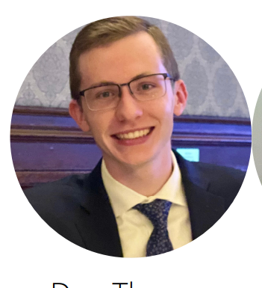

**Dan Thompson (He/Him/His)**

I am from Philadelphia, PA and currently major in forensic science with a concentration in biology. When it comes to tutoring, I am most proficient in STEM subjects. I am very comfortable with anything related to biology, chemistry, and math. Outside of school, I love to exercise, mainly running, and hanging out with friends around campus; especially in the new Bergami Center.

**Tutors:** BIOL-1121, BIOL-2253, BIOL-2254, CHEM-1115, CHEM-1116, CHEM-1117, CHEM-1118, CJST-1100, COMM-1130, ENGL-0100, FORS-2216, FORS-2217, HIST-1121, HNRS-1112, MATH-1117, MATH-2228, UNIV-1141

**Link:** <http://newhaven.campus.eab.com/pal/kcuQf_qKfr>

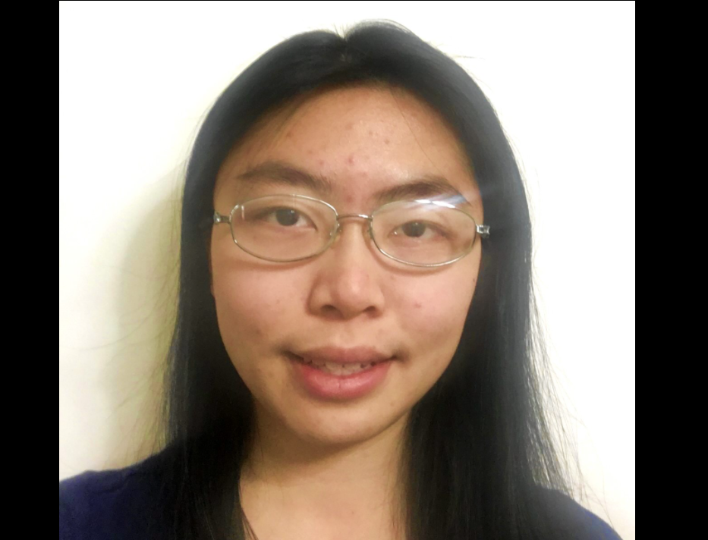

**Sharon Lin (She/Her/Hers)**

Hi, my name is Sharon and I am majoring in Forensic Science. I am graduating in May 2022. As a peer tutor I specialize in chemistry, but I also tutor biology, forensic science, and math. When I’m not at the CLR, I enjoy reading books and drawing.

**Tutors:** ARTS-1101, ARTS-1105, ARTS-1106, ARTS-4405, CHEM-1115, CHEM-1116, CHEM-1117, CHEM-1118, CHEM-2201, CHEM-2202, CHEM-2203, CHEM-2204, CHEM-2221, CHEM-4501, CJST-1100, FORS-2216, FORS-2217, FORS-3402, FORS-4403, FORS-4404, FORS-4451, HNRS-4450, MATH-1108, MATH-1110, MATH-1115, MATH-2228, PHYS-2205, UNIV-1141

**Link:** <http://newhaven.campus.eab.com/pal/hAPw7SA_yY>

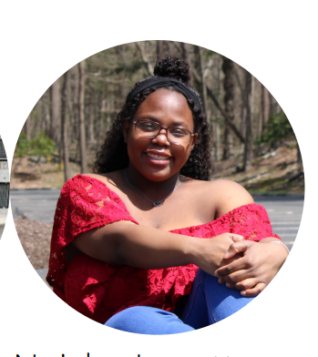

**Neisha Lovette (She/Her/Hers)**

I am a junior majoring in Forensic Science. This is my first year tutoring. My areas of expertise are chemistry, biology, forensic science, math, and beginner Russian. I love to read, play tennis, and my favorite animal is an elephant.

**Tutors:** BIOL-2254, CHEM-1115, CHEM-1116, CHEM-1118, CHEM-2203, CHEM-2204, CJST-1100, COMM-1130, FORS-2217, FORS-3402, HNRS-1112, PHYS-2205, RUSS-1101, UNIV-1141

**Link:** <http://newhaven.campus.eab.com/pal/mFKGD6njId>

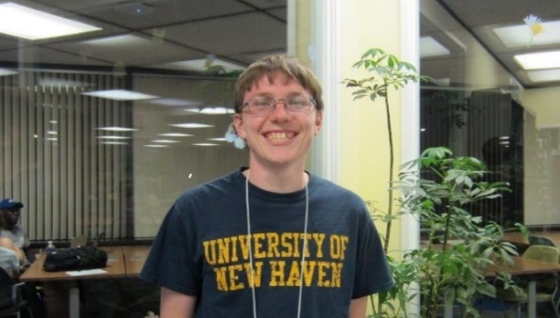

**Ben Hodge (He/Him/His)**

I am an adjunct professor in the University’s Department of Biology & Environmental Science. I have completed both my undergraduate and graduate careers at the University of New Haven. I have been with the CLR as a student and now professional tutor since Fall 2014. I also work as a Medical Technologist in the Virology Laboratory at Yale New Haven Hospital, in addition to teaching and tutoring at UNH.

**Tutors:** BIOL-1121, BIOL-1122, BIOL-1123, BIOL-1124, BIOL-1125, BIOL-1126, BIOL-2240, BIOL-2241, BIOL-2253, BIOL-2254, BIOL-2255, BIOL-2256, BIOL-2261, BIOL-2591, BIOL-2592, BIOL-2653, BIOL-3301, BIOL-3302, BIOL-3304, BIOL-3306, BIOL-3308, BIOL-3311, BIOL-3312, BIOL-3313, BIOL-3393, BIOL-4461,, BIOL-4462, BIOL-4470, BIOL-4493, BIOL-4501, BIOL-4503, BIOL-4506, BIOL-4511, BIOL-4513, BIOL-4520, BIOL-4521, BIOL-4522, CHEM-1103, CHEM-1105, CHEM-1106, CHEM-1115, CHEM-1116, CHEM-1117, CHEM-1118, CHEM-1120, CHEM-1121, CHEM-2201, CHEM-2202, CHEM-2203, CHEM-2204, CHEM-2211, CHEM-2212, CHEM-2221, CHEM-2222, CMBI-6601, CMBI-6602, CMBI-6603, CMBI-6606, CMBI-6607, CMBI-6608, CMBI-6611, CMBI-6613, CMBI-6617, CMBI-6620, CMBI-6621, CMBI-6622, CMBI-6625, CMBI-6633, CMBI-6636, CMBI-6647, CMBI-7607, EASC-1120, EASC-1121, FORS-2215, FORS-2216, FORS-2217, FORS-2250, FORS-3325, FORS-4403, FORS-4404, MATH-1103, MATH-1104, MATH-1108, MATH-1109, MATH-1110, MATH-1115, MATH-1117, MATH-1118, PHYS-1100, PHYS-1103, PHYS-1104, PHYS-1111, PHYS-1113, PHYS-1114, PHYS-1150, PHYS-1151, PHYS-2205, PHYS-2206, THEA-1131, THEA-1132, THEA-1150, THEA-3315

**Link:** <http://newhaven.campus.eab.com/pal/TEGdO-c3yD>

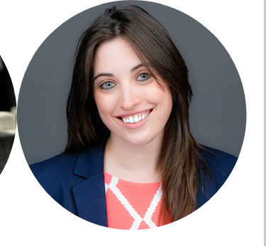

**Dr. Alyssa Marsico (She/Her/Hers)**

I received my Forensic Science and Chemistry Bachelor’s Degrees with a minor in Math from the University of New Haven. While there, I tutored in the CLR as a student tutor. Once I graduated, I went on to the University of Massachusetts in Amherst and earned my PhD in Analytical Chemistry. I now teach Forensic Science here at the University. My hobbies include spending time with my dogs, video games, hunting, fishing, disc golf, working out, off-roading, working on my truck, reading, playing guitar, and anything else to do outdoors!

**Tutors:** BIOL-1121, BIOL-1122, BIOL-1123, BIOL-1124, BIOL-2253, BIOL-2254, BIOL-2255, BIOL-2256, BIOL-2259, BIOL-2261, BIOL-2262, BIOL-3393, BIOL-4461, BIOL-4462, BIOL-4493, BIOL-4501, CHEM-1105, CHEM-1106, CHEM-1115, CHEM-1116, CHEM-1117, CHEM-1118, CHEM-2201, CHEM-2202, CHEM-2203, CHEM-2204, CHEM-2211, CHEM-2222, CHEM-3331, CHEM-3332, CHEM-3333, CHEM-3334, CHEM-3341, CHEM-4411, CHEM-4501, CJST-1100, CJST-2250, EASC-1120, FORS-2204, FORS-2215, FORS-2216, FORS-2217, FORS-2227, FORS-2250, FORS-3325, FORS-3402, FORS-4403, FORS-4404, FORS-4415, FORS-4416, FORS-6612, FORS-6613, FORS-6620, FORS-6621, FORS-6640, FORS-6641, FORS-6662, FORS-6698, MATH-1103, MATH-1104, MATH-1108, MATH-1110, MATH-1115, MATH-1117, MATH-1118, PHYS-1100, PHYS-1103, PHYS-1104, PHYS-1111, PHYS-1113, PHYS-1114, PHYS-1116, PHYS-1130 PHYS-1131, PHYS-1150, PHYS-1151

**Link:** <http://newhaven.campus.eab.com/pal/u2rtA9HU2k>