University of New Haven

Center for Learning Resources

Computer Lab Tutors

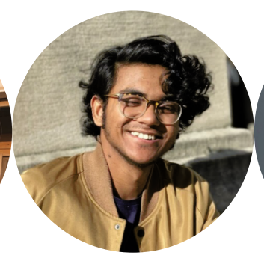

**Muntasir Hossain (He/Him/His)**

I am Muntasir Hossain and I am majoring in Computer Science with a minor in Mathematics. My specialty lies in most computer science and math courses, specifically C, C++, Java, Discrete Math, Probability and Statistics. Outside interests include hiking and traveling.

**Tutors:** COMM-1130, CSCI-1109, CSCI-1110, CSCI-1166, CSCI-2210, CSCI-2212, CSCI-2215, CSCI-2226, CSCI-2246, CSCI-3320, CSCI-3331, EASC-1102, EASC-1107, EASC-1109, ECON-1134, ELEC-3330, ENGL-4489, HNRS-1112, HNRS-4459, MATH-1117, MATH-1118, MATH-2203, MATH-3371, MATH-4472, THEA-1131

**Link:** <http://newhaven.campus.eab.com/pal/ViSJIMWfoX>

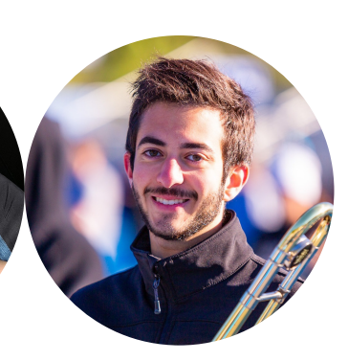

**Ben Greenfield (He/Him/His)**

I am a Computer Science major graduating in 2022. I am excited to help other students with their courses! When I am not tutoring at the computer lab in CLR, I like to build computers with friends.

**Tutors:** CSCI-1110, CSCI-2212, CSCI-2226, CSCI-2246, CSCI-3316, CSCI-3326, CSCI-3331, CSCI-3347, CSCI-4441, CSCI-6604, CSCI-6610, ELEC-1155, ELEC-3330

**Link:** <http://newhaven.campus.eab.com/pal/3hX_SE3HqQ>

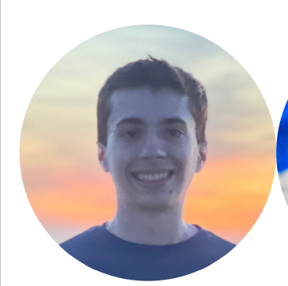

**Ben Placzek (He/Him/His)**

I am a senior majoring in Computer Science and minoring in Math. I have a passion for programming, calculus, and problem solving. I’m eager to assist students with their classes and provide advice to new students at the university. I spent the past year working as a software engineering intern at SIkorsky in Stratford, CT. When not working, I spend my time at the rec center, traveling, and listening to music.

**Tutors:** CSCI-1110, CSCI-1166, CSCI-2210, CSCI-2212, CSCI-2215, CSCI-2226, CSCI-2246, CSCI-3316, CSCI-3320, CSCI-3326, CSCI-3331, CSCI-3347, CSCI-4441, CSCI-6604,CSCI-6610, CSCI-6617, EASC-1107, ELEC-1155, ELEC-3330, ENVS-1101, ENVS-1102, HNRS-4452, MATH-1103, MATH-1108, MATH-1110, MATH-1115, MATH-1117, MATH-1118, MATH-1166, MATH-2203, MATH-3371

**Link:** <http://newhaven.campus.eab.com/pal/H-IXaEntlV>

**Killian Meehan (He/Him/His)**

Hello! I'm Killian Meehan, a Junior Cybersecurity and Networks major, following the NSA Cyber Operatives track. When not at a computer I love to perform in the theater (maybe you saw me in *Head over Heels* last semester) and play with my pets Valkyrie and Morrigan at home.

**Tutors:** CSCI 1109, CSCI 1110, EASC 1102, HNRS 1112, MATH 1115, SDEV 200, SDEV 1000, THEA 1131, BUSA 1000, COMM 1130, CSCI 1166, CSCI 2212, MATH 1117, CSCI 3351, CSCI 2215, CSCI 2226, CSCI 2246, ELEC 1155, HNRS 4457, THEA 3332, CSCI 3331, CSCI 3338, CSCI 4449, ELEC 3330, THEA 4450, CSCI 3316, CSCI 3347, CSCI 3398, CSCI 4448, HNRS 4459, PHYS 1150, PHYS 1151, THEA 1002, THEA 3350

**Link:** <https://newhaven.campus.eab.com/pal/fimuQT_XFo>