University of New Haven

Center for Learning Resources

Criminal Justice and Legal Studies Tutors

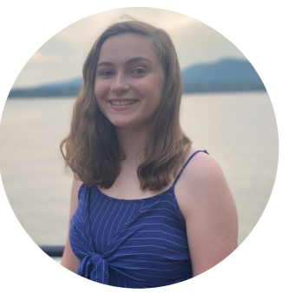

**Mallory Ferrick (She/Her/Hers)**

I’m Mallory and I’m a senior here at UNH. I’m majoring in Criminal Justice with a concentration in Crime Analysis and a minor in Sociology. On campus, I’m part of Alpha Lambda Delta and Alpha Phi Sigma honor societies, as well as the Honors Program. Outside of school, I like to read and listen to music. My favorite bands are Queen and The Beatles.

**Tutors:** CJST-1100, CJST-1102, CJST-2201, CJST-2208, CJST-2217,CJST-2250, CJST-2251, CJST-3311, CJST-3340, CJST-3399, CJST-4452, CJST-4557, COMM-1130, MUSC-1111, MUSC-4453, MUSC-4455, PSYC-1111, SOCI-1113, SOCI-3320, SOCI-4441, UNIV-1141

**Link:** <http://newhaven.campus.eab.com/pal/kBAwBgnhw5>

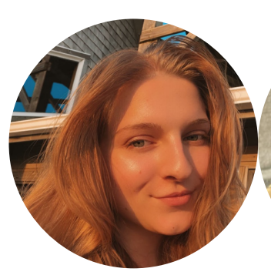

**Alexa Moyer (She/Her/Hers)**

I’m a Legal Studies major with minors in Political Science and Professional & Technical Writing! My tutoring specialty is Legal Studies. Outside of classes, I’m an officer for the Mock Trial Team, and an EBoard member for the Legal Society and the Pre-Law Society. In my free time, I enjoy playing Animal Crossing and trying to find a Netflix show I haven’t watched already.

**Tutors:** COMM-1130, ENGL-1112, ENGL-2200, ENGL-2220, ENGL-2230, HIST-1101, HIST-1102, LSTD-1100, LSTD-2201, LSTD-2238, LSTD-2240, LSTD-2241, LSTD-3301, LSTD-4457, PHIL-2222, PSCI-1121, PSCI-1122, PSCI-2222, PSCI-3308, UNIV-1141

**Link:** <http://newhaven.campus.eab.com/pal/Bkj36enepF>