University of New Haven
Center for Learning Resources
Dental Hygiene

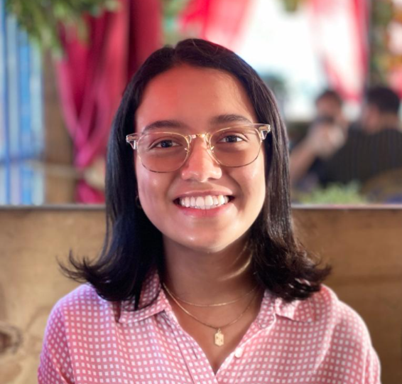
Hailey Ortiz Rivera (She/Her/Hers)
Hello! I am the dental hygiene peer tutor and I’m a junior in the program. I’m also one of the ambassadors for the Dental Hygiene program. I love to learn about teeth, and anything related to oral health. Outside of my major, I enjoy drawing, playing video games, and spending time with my family and friends.
Tutors: CHEM-1105, CHEM-1106, DHYG-1110, SOCI-1113, BIOL-1121, BIOL-1123, DIET-1160, DIET-1175, HLTH-2200, DHYG-2215, DHYG-2216, HLTH-2230, DHYG-2240, DHYG-2241, BIOL-2259, BIOL-2260, BIOL-2261, BIOL-2262, BIOL-2263, DHYG-3327
Link: https://newhaven.campus.eab.com/pal/qn6rGI28Oh

