University of New Haven

Center for Learning Resources

EASC and Electrical Engineering Tutors

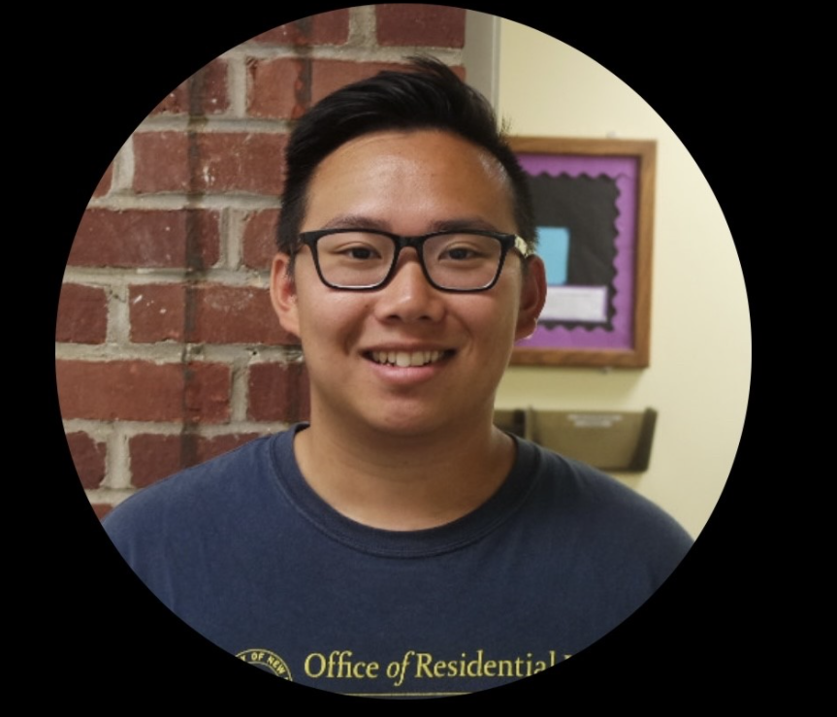

**Thomas Hong (He/Him/His)**

I have Bachelor degrees in Forensic Science and Chemical Engineering as well as a Masters in Chemistry. During my free time, I enjoy playing tennis. I tutor chemistry, engineering, math, and physics.

**Tutors:** BIOL-2261, BIOL-4461, BIOM-6610, CHEM-1100, CHEM-1106, CHEM-1111, CHEM-1115, CHEM-1116, CHEM-1117, CHEM-1118, CHEM-2201, CHEM-2202, CHEM-2203, CHEM-2204, CHEM-2211, CHEM-2212, CHEM-3331, CHEM-3332, CHEM-3333, CHEM-3334, CHEM-6607, CHEM-6615, CHEM-6682 CHME-2220, CHME-3311, CHME-3315, CHME-3316, CHME-3321, CHME-3362, CHME-4401, CHME-4415, CHME-4461, CHME-4462, CHME-4497, CHME-4498, EASC-1101, EASC-1102, EASC-1107, EASC-1109, EASC-1112, EASC-1120, EASC-1121, EASC-2211, EASC-2213, EASC-2224, EASC-2232, PHYS-1100, PHYS-1103, PHYS-1104, PHYS-1111, PHYS-1113, PHYS-1114, PHYS-1130, PHYS-1131, PHYS-1150, PHYS-1151

**Link:** <http://newhaven.campus.eab.com/pal/D15NljbUSo>

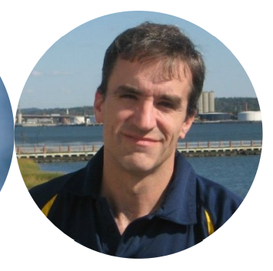

**David Low (He/Him/His)**

I have been tutoring Engineering, Math, and Physics at the CLR for over ten years. In addition, I teach all three of those subjects elsewhere. I am happy to be back on campus this semester and look forward to working with all of the students here at UNH.

**Tutors:** EASC-1107, EASC-1109, EASC-1112, EASC-2211, EASC-2224, MATH-1017, MATH-1103, MATH-1104, MATH-1108, MATH-1110, MATH-1115 MATH-1117, MATH-1118, MATH-1121, MATH-1166, MATH-2203, MATH-2204, PHYS-1100, PHYS-1103, PHYS-1104, PHYS-1111, PHYS-1113, PHYS-1114, PHYS-1116, PHYS-1130, PHYS-1131, PHYS-1150, PHYS-1151, PHYS-2203, PHYS-2204, PHYS-2205, PHYS-2206

**Link:** <http://newhaven.campus.eab.com/pal/iGTVAYJ8Kr>

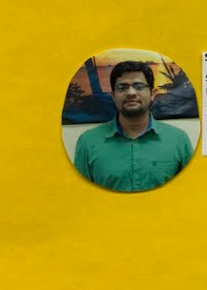

**Syed Ravzi (He/Him/His)**

I have been a professional tutor at the CLR since Fall 2016. I graduated from UNH with a Bachelors and Masters in Electrical Engineering. In my spare time, I am a Nouha Khwan (one who recites prayers).

**Tutors:** CHEM-1111, CHEM-1115, EASC-1107, EASC-1109, EASC-1112, EASC-2211, EASC-2230, EASC-2232, ELEC-1155, ELEC-2235, ELEC-2247, ELEC-3302, ELEC-6637, MATH-1017, MATH-1103, MATH-1108, MATH-1110, MATH-1115, MATH-1117, MATH-1118, MATH-2203, MATH-2204, MATH-4450, PHYS-1100, PHYS-1103, PHYS-1104, PHYS-1111, PHYS-1113, PHYS-1114, PHYS-1150, PHYS-1151, PHYS-2205, PHYS-2206

**Link:** <http://newhaven.campus.eab.com/pal/kFjR4kyAAR>