University of New Haven

Center for Learning Resources

Economics, Finance, and Accounting Tutors



**Sachi Patel (She/Her/Hers)**

I am a graduate student pursing a Masters in Taxation and have my undergraduate degree in Accounting from the University of New Haven. I am a business tutor and in my free time I enjoy spending time with family, friends and pets.

**Tutors:** ACCT-1101, ACCT-2221, ACCT-4431, ACCT-4433, ACCT-4435, ACCT-4596, BUSL-1101, CJST-1100, COMM-1130, ENGL-1112, HTMG-3306, ITAL-1101, MATH-1115, MGMT-2240, MGMT-4550, MKTG-2200, PSCI-1101, PSCI-1121

**Link:** <http://newhaven.campus.eab.com/pal/VkriefGd7M>

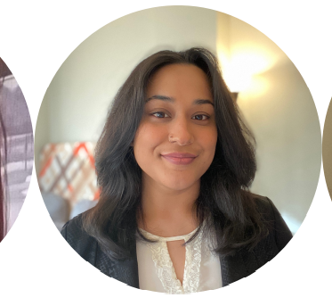

**Aakriti Tiwari (She/Her/Hers)**

I am currently doing my MBA in Data Analytics at UNH. I have a Bachelors degree in Finance from UB. My tutoring courses for the semester are mostly first year MBA courses along with some data analytics electives. Apart from teaching and learning, I enjoy hiking, reading poetry, and trying new restaurants.

**Tutors:** ACCT-6619, BANL-6100, ECON-6633, ECON-6644, FINC-6601, MGMT-6663, MGMT-6668, MKTG-6610, QANL-6625

**Link:** <http://newhaven.campus.eab.com/pal/IKhVcnVGxd>

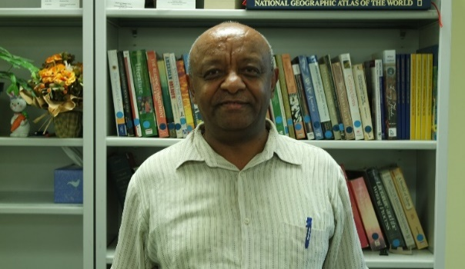

**Alem Lemma (He/Him/His)**

Hello, I am Dr. Lemma and I hold MA degrees in Economic Policy Making, Economics and International Development and a PhD in Development Economics and Applied Econometrics. I tutor math, quantitative analysis, and statistics.

**Tutors:** CJST-2251, ECON-1133, ECON-1134, ECON-3342, ECON-6633, FINC-1123, MATH-1103, MATH-1104, MATH-1108, MATH-1110, MATH-1115, MATH-1117, MATH-1118, MATH-1121, MATH-2228, QANL-3380

**Link:** [**http://newhaven.campus.eab.com/pal/ohdNOa8i9k**](http://newhaven.campus.eab.com/pal/ohdNOa8i9k)

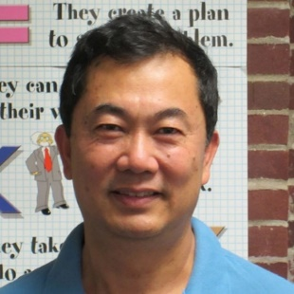

**Dr. Kevin Lin (He/Him/His)**

I hold a PhD in Synthetic Chemistry. I work as a medicinal chemist and an adjunct professor in organic chemistry labs. As a professional tutor, I am here to help with all chemistry courses from undergraduate to graduate and mathematics I/II.

**Tutors:** BIOL-2261, BIOL-4461, BIOL-4462, CHEM-1105, CHEM-1106, CHEM-1115, CHEM-1116, CHEM-1117, CHEM-1118, CHEM-2201, CHEM-2202, CHEM-2203, CHEM-2204, CHEM-2211, CHEM-2212, CHEM-2221, CHEM-2222, CHEM-3331, CHEM-3332, CHEM-3333, CHEM-3341, CHEM-4411, CHEM-6615, CHEM-6631, CHIN-1101, CHIN-1102, CHIN-3301, MATH-1103, MATH-1104, MATH-1108, MATH-1110, MATH-1115, MATH-1117, MATH-1118, MATH-1121, MATH-2203

**Link:** <http://newhaven.campus.eab.com/pal/eEPs_mmiQX>