University of New Haven

Center for Learning Resources

Forensic Science Tutors

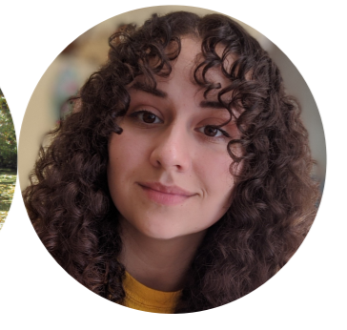

**Nicole Miklinski (She/Her/Hers)**

I’m a junior majoring in Forensic Biology and minoring in Chemistry. I am an undergraduate Forensic Science peer tutor as well as Biology and Math. I am also a General Chemistry Learning Assistant. My hobbies include watching and discussing true crime documentaries, reading Stephen King novels, and playing with my cats.

**Tutors:** BIOL-2253, BIOL-2254, BIOL-3306, BIOL-4591, CHEM-1115, CHEM-1117, CHEM-1118, CHEM-2203, CHEM-2204, COMM-1130, ENGL-0100, FORS-2216, FORS-2217, HIST-1121, HNRS-1112, MATH-2228, PSYC-1111, SPAN-1101, UNIV-1141.

**Link:** <http://newhaven.campus.eab.com/pal/8iSJgBbqmq>

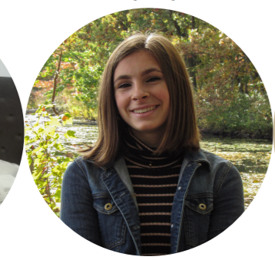

**Mackenzie Pavlik (She/Her/Hers)**

I am a sophomore majoring in Forensic Science with a concentration in chemistry. I will be tutoring forensic science, chemistry, biology, and math! I am also a part of the gymnastics club.

**Tutors:** BIOL-2253, BIOL-2253, BIOL-2254, CHEM-1115, CHEM-1116, CHEM-1117,CHEM-1118, CHEM-2201, CHEM-2202, CHEM-2203, CHEM-2204, CJST-1100, FORS-2216, FORS-2217, HNRS-1112, MATH-1117, MATH-1118, MATH-2203, MATH-2228, PHYS-1103, UNIV-1141

**Link:** <http://newhaven.campus.eab.com/pal/Olf3efsaw8>

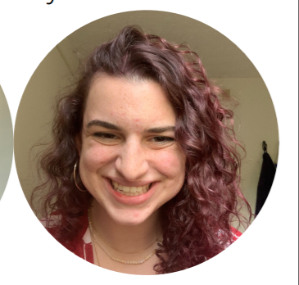

**Rayna Kruzona (She/Her/Hers)**

Hello! My name is Rayna and I am a Forensic Science major with a concentration in Biology. I am a third-year student at the University of New Haven, and I tutor forensic sciences and biology. I play rugby, have houseplants, and enjoy painting!

**Tutors:** BIOL-2253, BIOL-2254, BIOL-2256, BIOL-3393, CHEM-1115, CHEM-1117, CHEM-1118, CHEM-2203, COMM-1130, ENGL-1112, FORS-2216 FORS-2217, FORS-3402, HIST-1101, MATH-1117, PHIL-2222, PHYS-1150, PHYS-1151, PHYS-2205, PHYS-2206, SPAN-1101

**Link:** <http://newhaven.campus.eab.com/pal/hbvOFou_K7>

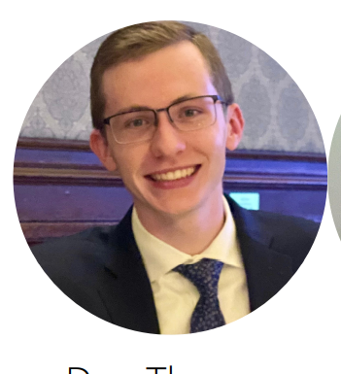

**Dan Thompson (He/Him/His)**

I am from Philadelphia, PA and currently major in forensic science with a concentration in biology. When it comes to tutoring, I am most proficient in STEM subjects. I am very comfortable with anything related to biology, chemistry, and math. Outside of school, I love to exercise, mainly running, and hanging out with friends around campus; especially in the new Bergami Center.

**Tutors:** BIOL-1121, BIOL-2253, BIOL-2254, CHEM-1115, CHEM-1116, CHEM-1117, CHEM-1118, CJST-1100, COMM-1130, ENGL-0100, FORS-2216, FORS-2217, HIST-1121, HNRS-1112, MATH-1117, MATH-2228, UNIV-1141

**Link:** <http://newhaven.campus.eab.com/pal/kcuQf_qKfr>

**Olivia McCavanagh**

I am from Andover, CT and I am majoring in forensic science with a concentration in biology. This semester I will be a Learning Assistant for Gen Chem I. Outside of school, I enjoy photography, reading, and hanging out with my friends around campus.

**Tutors:** FORS-1100, CHEM-1115, CHEM-1116, CHEM-1117, CHEM-1118, CHEM-2201, FORS-2217, ARTS-2233, BIOL-2254, BIOL-2256, BIOL-3306

**Link:** <https://newhaven.campus.eab.com/pal/ax-_hEeN1D>

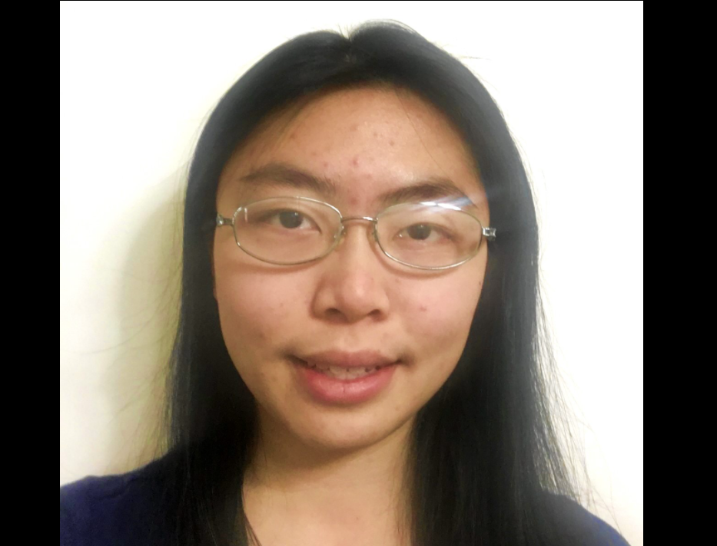

**Sharon Lin (She/Her/Hers)**

Hi, my name is Sharon and I am majoring in Forensic Science. I am graduating in May 2022. As a peer tutor I specialize in chemistry, but I also tutor biology, forensic science, and math. When I’m not at the CLR, I enjoy reading books and drawing.

**Tutors:** ARTS-1101, ARTS-1105, ARTS-1106, ARTS-4405, CHEM-1115, CHEM-1116, CHEM-1117, CHEM-1118, CHEM-2201, CHEM-2202, CHEM-2203, CHEM-2204, CHEM-2221, CHEM-4501, CJST-1100, FORS-2216, FORS-2217, FORS-3402, FORS-4403, FORS-4404, FORS-4451, HNRS-4450, MATH-1108, MATH-1110, MATH-1115, MATH-2228, PHYS-2205, UNIV-1141

**Link:** <http://newhaven.campus.eab.com/pal/hAPw7SA_yY>

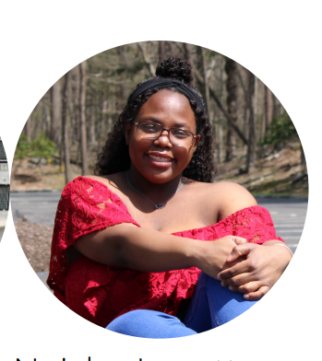

**Neisha Lovette (She/Her/Hers)**

I am a junior majoring in Forensic Science. This is my first year tutoring. My areas of expertise are chemistry, biology, forensic science, math, and beginner Russian. I love to read, play tennis, and my favorite animal is an elephant.

**Tutors:** BIOL-2254, CHEM-1115, CHEM-1116, CHEM-1118, CHEM-2203, CHEM-2204, CJST-1100, COMM-1130, FORS-2217, FORS-3402, HNRS-1112, PHYS-2205, RUSS-1101, UNIV-1141

**Link:** <http://newhaven.campus.eab.com/pal/mFKGD6njId>

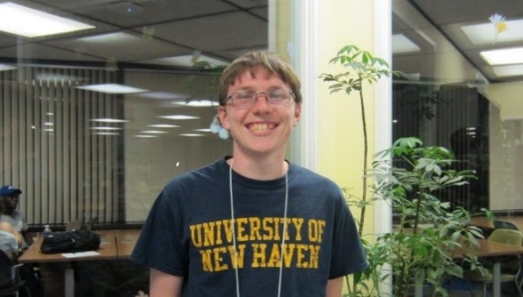

**Ben Hodge (He/Him/His)**

I am an adjunct professor in the University’s Department of Biology & Environmental Science. I have completed both my undergraduate and graduate careers at the University of New Haven. I have been with the CLR as a student and now professional tutor since Fall 2014. I also work as a Medical Technologist in the Virology Laboratory at Yale New Haven Hospital, in addition to teaching and tutoring at UNH.

**Tutors:** BIOL-1121, BIOL-1122, BIOL-1123, BIOL-1124, BIOL-1125, BIOL-1126, BIOL-2240, BIOL-2241, BIOL-2253, BIOL-2254, BIOL-2255, BIOL-2256, BIOL-2261, BIOL-2591, BIOL-2592, BIOL-2653, BIOL-3301, BIOL-3302, BIOL-3304, BIOL-3306, BIOL-3308, BIOL-3311, BIOL-3312, BIOL-3313, BIOL-3393, BIOL-4461,, BIOL-4462, BIOL-4470, BIOL-4493, BIOL-4501, BIOL-4503, BIOL-4506, BIOL-4511, BIOL-4513, BIOL-4520, BIOL-4521, BIOL-4522, CHEM-1103, CHEM-1105, CHEM-1106, CHEM-1115, CHEM-1116, CHEM-1117, CHEM-1118, CHEM-1120, CHEM-1121, CHEM-2201, CHEM-2202, CHEM-2203, CHEM-2204, CHEM-2211, CHEM-2212, CHEM-2221, CHEM-2222, CMBI-6601, CMBI-6602, CMBI-6603, CMBI-6606, CMBI-6607, CMBI-6608, CMBI-6611, CMBI-6613, CMBI-6617, CMBI-6620, CMBI-6621, CMBI-6622, CMBI-6625, CMBI-6633, CMBI-6636, CMBI-6647, CMBI-7607, EASC-1120, EASC-1121, FORS-2215, FORS-2216, FORS-2217, FORS-2250, FORS-3325, FORS-4403, FORS-4404, MATH-1103, MATH-1104, MATH-1108, MATH-1109, MATH-1110, MATH-1115, MATH-1117, MATH-1118, PHYS-1100, PHYS-1103, PHYS-1104, PHYS-1111, PHYS-1113, PHYS-1114, PHYS-1150, PHYS-1151, PHYS-2205, PHYS-2206, THEA-1131, THEA-1132, THEA-1150, THEA-3315

**Link:** <http://newhaven.campus.eab.com/pal/TEGdO-c3yD>

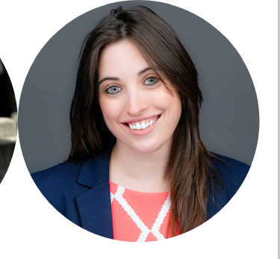

**Dr. Alyssa Marsico (She/Her/Hers)**

I received my Forensic Science and Chemistry Bachelor’s Degrees with a minor in Math from the University of New Haven. While there, I tutored in the CLR as a student tutor. Once I graduated, I went on to the University of Massachusetts in Amherst and earned my PhD in Analytical Chemistry. I now teach Forensic Science here at the University. My hobbies include spending time with my dogs, video games, hunting, fishing, disc golf, working out, off-roading, working on my truck, reading, playing guitar, and anything else to do outdoors!

**Tutors:** BIOL-1121, BIOL-1122, BIOL-1123, BIOL-1124, BIOL-2253, BIOL-2254, BIOL-2255, BIOL-2256, BIOL-2259, BIOL-2261, BIOL-2262, BIOL-3393, BIOL-4461, BIOL-4462, BIOL-4493, BIOL-4501, CHEM-1105, CHEM-1106, CHEM-1115, CHEM-1116, CHEM-1117, CHEM-1118, CHEM-2201, CHEM-2202, CHEM-2203, CHEM-2204, CHEM-2211, CHEM-2222, CHEM-3331, CHEM-3332, CHEM-3333, CHEM-3334, CHEM-3341, CHEM-4411, CHEM-4501, CJST-1100, CJST-2250, EASC-1120, FORS-2204, FORS-2215, FORS-2216, FORS-2217, FORS-2227, FORS-2250, FORS-3325, FORS-3402, FORS-4403, FORS-4404, FORS-4415, FORS-4416, FORS-6612, FORS-6613, FORS-6620, FORS-6621, FORS-6640, FORS-6641, FORS-6662, FORS-6698, MATH-1103, MATH-1104, MATH-1108, MATH-1110, MATH-1115, MATH-1117, MATH-1118, PHYS-1100, PHYS-1103, PHYS-1104, PHYS-1111, PHYS-1113, PHYS-1114, PHYS-1116, PHYS-1130 PHYS-1131, PHYS-1150, PHYS-1151

**Link:** <http://newhaven.campus.eab.com/pal/u2rtA9HU2k>

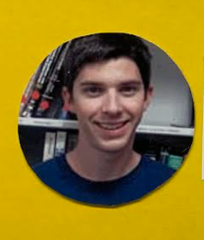

**Rob Harvey (He/Him/His)**

I am a lecturer in the Chemistry Department. I have been tutoring since 2009. When the weather is nice, you can find me hiking, biking, or kayaking around CT. If not, you’ll find me inside watching Netflix and solving Rubix Cubes.

**Tutors:** CHEM-1100, CHEM-1105, CHEM-1106, CHEM-1111, CHEM-1115, CHEM-1116, CHEM-1117, CHEM-1118, CHEM-2201, CHEM-2202, CHEM-2203, CHEM-2204, CHEM-2211, CHEM-2212, CHEM-2221, CHEM-2222, CHEM-3331, CHEM-3332, CHEM-3333, CHEM-3334, COOP-7701, FORS-2215, FORS-2216, FORS-2217, FORS-3402, FORS-4403, FORS-4404, FORS-4415, MATH-1017, MATH-1103, MATH-1104, MATH-1108, MATH-1110, MATH-1115, MATH-1117, MATH-1118, MATH-1121, PHYS-1100, PHYS-1103, PHYS-1104, PHYS-1111, PHYS-1113, PHYS-1114, PHYS-1116, PHYS-1130, PHYS-1131, PHYS-1150, PHYS-1151

**Link:** <http://newhaven.campus.eab.com/pal/ca_7E2P1tE>