University of New Haven
Center for Learning Resources
Health Sciences Tutor

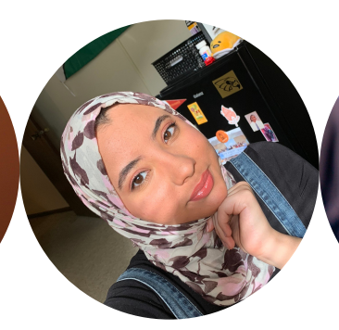
Luzan JadKarim (She/Her/Hers)
My name is Lu and I'm a current MPH student. I've previously tutored Biology, Psychology, and Chemistry at my undergrad institution. Currently, I'm tutoring Public Health courses. My hobbies include watching anime, baking, gaming, and working out!
Tutors: PUBH-6600, PUBH-6615, PUBH-6625, PUBH-6645, PUBH-6655, PUBH-6660, PUBH-6672
Link: http://newhaven.campus.eab.com/pal/RdEkErymG6

