University of New Haven
Center for Learning Resources
Humanities and Social Sciences Tutor

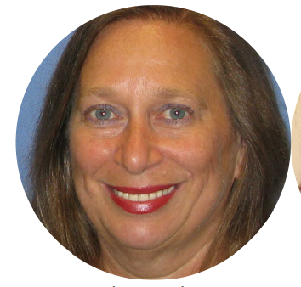
Beverly Salzman (She/Her/Hers)
Hello everyone, I am a Psychology adjunct professor here at the University as well as a multi-subject tutor. I have two Bachelor of Science degrees from the University of Bridgeport, along with Master’s degrees in Business Administration from Sacred Heart University and in Psychology from Capella University. I look forward to helping you out this semester.
Tutors: COMM-1100, COMM-1101, COMM-1102, COMM-1109, COMM-1130, COMM-3306, COMM-3309, COMM-3317, COMM-3340, COMM-4420, COMM-4453, COMM-4597, COMM-4598, ENGL-1103, ENGL-1104, ENGL-1112, ENGL-1113, ENGL-1114, ENGL-2220, ENGL-2230, ENGL-3300, ENGL-3342, MGMT-2210, MGMT-2240, PSCI-1101, PSCI-1121, PSCI-2241, PSCI-3304, PSYC-1111, PSYC-1112, PSYC-2216, PSYC-2217, PSYC-2225, PSYC-2336, PSYC-3300, PSYC-3321, PSYC-3330, PSYC-3351, PSYC-3370, PSYC-3375, SOCI-1113 SOCI-1115, SOCI-2214, SOCI-3320, SOCI-3321, UNIV-1141
Link: http://newhaven.campus.eab.com/pal/btRcue49rB
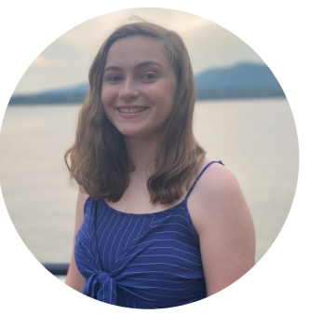
Mallory Ferrick (She/Her/Hers)
I’m Mallory and I’m a senior here at UNH. I’m majoring in Criminal Justice with a concentration in Crime Analysis and a minor in Sociology. On campus, I’m part of Alpha Lambda Delta and Alpha Phi Sigma honor societies, as well as the Honors Program. Outside of school, I like to read and listen to music. My favorite bands are Queen and The Beatles.
Tutors: CJST-1100, CJST-1102, CJST-2201, CJST-2208, CJST-2217,CJST-2250, CJST-2251, CJST-3311, CJST-3340, CJST-3399, CJST-4452, CJST-4557, COMM-1130, MUSC-1111, MUSC-4453, MUSC-4455, PSYC-1111, SOCI-1113, SOCI-3320, SOCI-4441, UNIV-1141
Link: http://newhaven.campus.eab.com/pal/kBAwBgnhw5
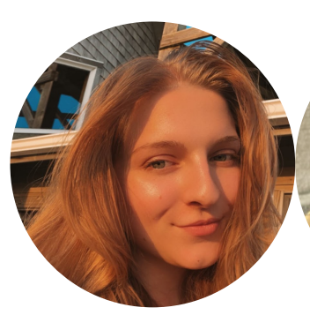
Alexa Moyer (She/Her/Hers)
I’m a Legal Studies major with minors in Political Science and Professional & Technical Writing. My tutoring specialty is Legal Studies. Outside of classes, I’m an officer for the Mock Trial Team, and an EBoard member for the Legal Society and the Pre-Law Society. In my free time, I enjoy playing Animal Crossing and trying to find a Netflix show I haven’t watched already.
Tutors: COMM-1130, ENGL-1112, ENGL-2200, ENGL-2220, ENGL-2230, HIST-1101, HIST-1102, LSTD-1100, LSTD-2201, LSTD-2238, LSTD-2240, LSTD-2241, LSTD-3301, LSTD-4457, PHIL-2222, PSCI-1121, PSCI-1122, PSCI-2222, PSCI-3308, UNIV-1141
Link: http://newhaven.campus.eab.com/pal/Bkj36enepF

