University of New Haven

Center for Learning Resources

Mathematics Tutors

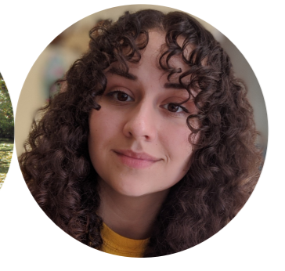

**Nicole Miklinski (She/Her/Hers)**

I’m a junior majoring in Forensic Biology and minoring in Chemistry. I am an undergraduate Forensic Science peer tutor as well as Biology and Math. I am also a General Chemistry Learning Assistant. My hobbies include watching and discussing true crime documentaries, reading Stephen King novels, and playing with my cats.

**Tutors:** BIOL-2253, BIOL-2254, BIOL-3306, BIOL-4591, CHEM-1115, CHEM-1117, CHEM-1118, CHEM-2203, CHEM-2204, COMM-1130, ENGL-0100, FORS-2216, FORS-2217, HIST-1121, HNRS-1112, MATH-2228, PSYC-1111, SPAN-1101, UNIV-1141.

**Link:** <http://newhaven.campus.eab.com/pal/8iSJgBbqmq>

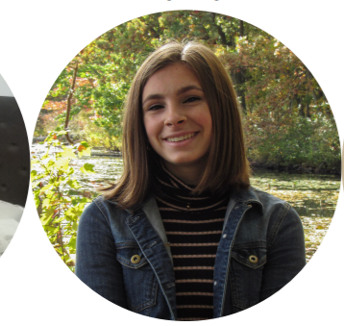

**Mackenzie Pavlik (She/Her/Hers)**

I am a sophomore majoring in Forensic Science with a concentration in chemistry. I will be tutoring forensic science, chemistry, biology, and math. I am also a part of the gymnastics club.

**Tutors:** BIOL-2253, BIOL-2253, BIOL-2254, CHEM-1115, CHEM-1116, CHEM-1117,CHEM-1118, CHEM-2201, CHEM-2202, CHEM-2203, CHEM-2204, CJST-1100, FORS-2216, FORS-2217, HNRS-1112, MATH-1117, MATH-1118, MATH-2203, MATH-2228, PHYS-1103, UNIV-1141

**Link:** <http://newhaven.campus.eab.com/pal/Olf3efsaw8>

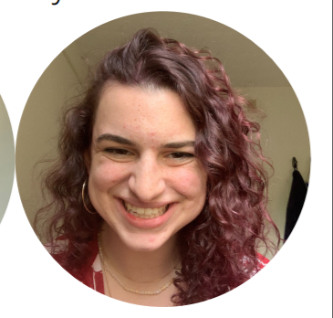

**Rayna Kruzona (She/Her/Hers)**

Hello! My name is Rayna and I am a Forensic Science major with a concentration in Biology. I am a third-year student at the University of New Haven, and I tutor forensic sciences and biology. I play rugby, have houseplants, and enjoy painting.

**Tutors:** BIOL-2253, BIOL-2254, BIOL-2256, BIOL-3393, CHEM-1115, CHEM-1117, CHEM-1118, CHEM-2203, COMM-1130, ENGL-1112, FORS-2216 FORS-2217, FORS-3402, HIST-1101, MATH-1117, PHIL-2222, PHYS-1150, PHYS-1151, PHYS-2205, PHYS-2206, SPAN-1101

**Link:** <http://newhaven.campus.eab.com/pal/hbvOFou_K7>

**Hang (Chelsea) Su**

My name is Hang Su or you can call me Chelsea. I am a junior majoring in Mathematics with a Physics minor. I tutor mainly math, physics, biology, and chemistry. I am also the Learning Assistant for a Calculus II course.

**Tutors:** BIOL-2253, BIOL-2254, CHEM-1115, CHEM-1116, CHEM-1117, CHEM-1118, CJST-1100, COMM-1130, FORS-2216, FORS-2217, MATH-1118, MATH-2203, MATH-2228, MUSC-1117, PHYS-1150, PHYS-2205, SDEV-1152, UNIV-1141

**Link:** <http://newhaven.campus.eab.com/pal/vL1n1VvsqR>

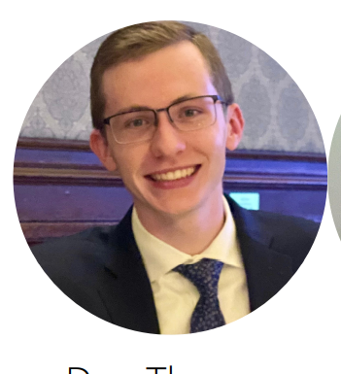

**Dan Thompson (He/Him/His)**

I am from Philadelphia, PA and currently major in forensic science with a concentration in biology. When it comes to tutoring, I am most proficient in STEM subjects. I am very comfortable with anything related to biology, chemistry, and math. Outside of school, I love to exercise, mainly running, and hanging out with friends around campus; especially in the new Bergami Center.

**Tutors:** BIOL-1121, BIOL-2253, BIOL-2254, CHEM-1115, CHEM-1116, CHEM-1117, CHEM-1118, CJST-1100, COMM-1130, ENGL-0100, FORS-2216, FORS-2217, HIST-1121, HNRS-1112, MATH-1117, MATH-2228, UNIV-1141

**Link:** <http://newhaven.campus.eab.com/pal/kcuQf_qKfr>

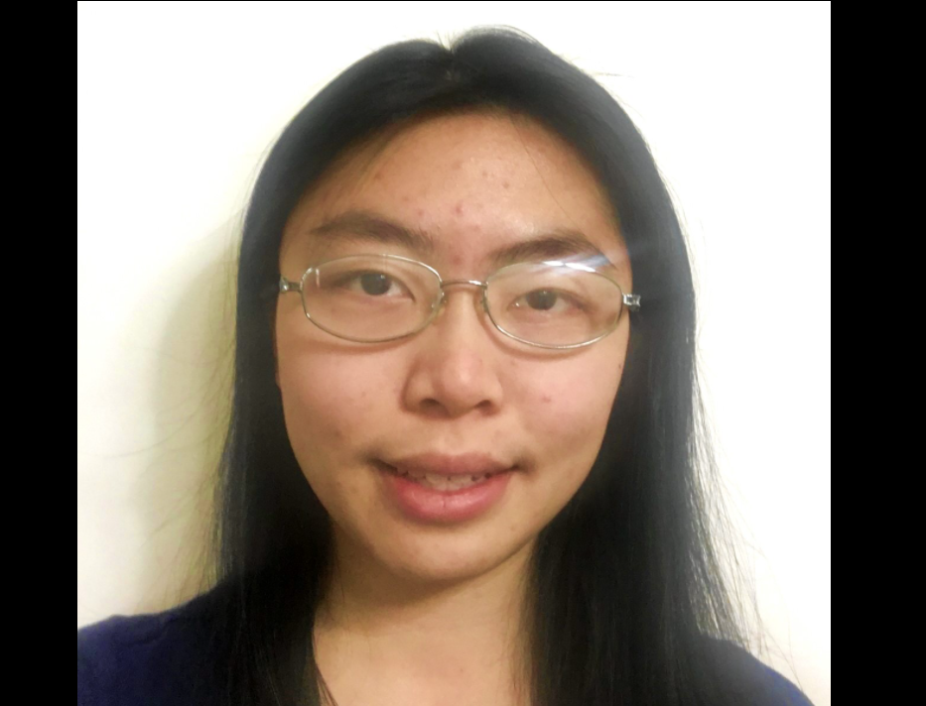

**Sharon Lin (She/Her/Hers)**

Hi, my name is Sharon and I am majoring in Forensic Science. I am graduating in May 2022. As a peer tutor I specialize in chemistry, but I also tutor biology, forensic science, and math. When I’m not at the CLR, I enjoy reading books and drawing.

**Tutors:** ARTS-1101, ARTS-1105, ARTS-1106, ARTS-4405, CHEM-1115, CHEM-1116, CHEM-1117, CHEM-1118, CHEM-2201, CHEM-2202, CHEM-2203, CHEM-2204, CHEM-2221, CHEM-4501, CJST-1100, FORS-2216, FORS-2217, FORS-3402, FORS-4403, FORS-4404, FORS-4451, HNRS-4450, MATH-1108, MATH-1110, MATH-1115, MATH-2228, PHYS-2205, UNIV-1141

**Link:** <http://newhaven.campus.eab.com/pal/hAPw7SA_yY>

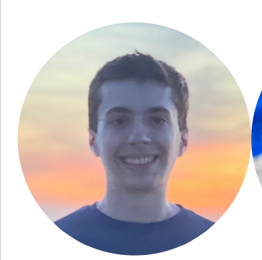

**Ben Placzek (He/Him/His)**

I am a senior majoring in Computer Science and minoring in Math. I have a passion for programming, calculus, and problem solving. I’m eager to assist students with their classes and provide advice to new students at the university. I spent the past year working as a software engineering intern at SIkorsky in Stratford, CT. When not working, I spend my time at the rec center, traveling, and listening to music.

**Tutors:** CSCI-1110, CSCI-1166, CSCI-2210, CSCI-2212, CSCI-2215, CSCI-2226, CSCI-2246, CSCI-3316, CSCI-3320, CSCI-3326, CSCI-3331, CSCI-3347, CSCI-4441, CSCI-6604,CSCI-6610, CSCI-6617, EASC-1107, ELEC-1155, ELEC-3330, ENVS-1101, ENVS-1102, HNRS-4452, MATH-1103, MATH-1108, MATH-1110, MATH-1115, MATH-1117, MATH-1118, MATH-1166, MATH-2203, MATH-3371

**Link:** <http://newhaven.campus.eab.com/pal/H-IXaEntlV>

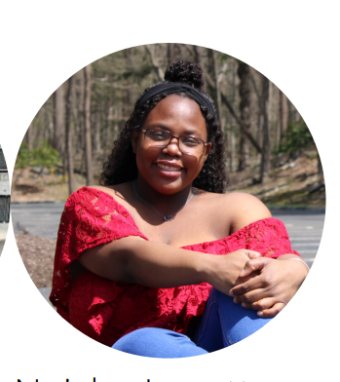

**Neisha Lovette (She/Her/Hers)**

I am a junior majoring in Forensic Science. This is my first year tutoring. My areas of expertise are chemistry, biology, forensic science, math, and beginner Russian. I love to read, play tennis, and my favorite animal is an elephant.

**Tutors:** BIOL-2254, CHEM-1115, CHEM-1116, CHEM-1118, CHEM-2203, CHEM-2204, CJST-1100, COMM-1130, FORS-2217, FORS-3402, HNRS-1112, PHYS-2205, RUSS-1101, UNIV-1141

**Link:** <http://newhaven.campus.eab.com/pal/mFKGD6njId>

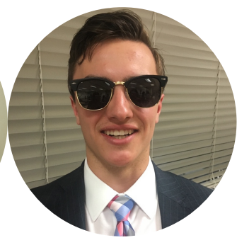

**Calvin Ponzio (He/Him/His)**

I major in Fire Science and am in Army ROTC. I play lacrosse, love to ski, work as a ski instructor, and am a firefighter at home.

**Tutors:** CHEM-1105, CJST-1100, CJST-2201, CJST-2217, COMM-1130, ENGL-1112, FIRE-1102, FIRE-2201, FIRE-2204, FIRE-2205, FIRE-3302, FIRE-3313, FIRE-3314, FIRE-3325, MILS-2202, MUSC-1111, UNIV-1141

**Link:** <http://newhaven.campus.eab.com/pal/ObD_xRx3Ej>

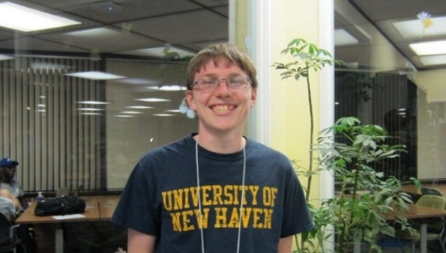

**Ben Hodge (He/Him/His)**

I am an adjunct professor in the University’s Department of Biology & Environmental Science. I have completed both my undergraduate and graduate careers at the University of New Haven. I have been with the CLR as a student and now professional tutor since Fall 2014. I also work as a Medical Technologist in the Virology Laboratory at Yale New Haven Hospital, in addition to teaching and tutoring at UNH.

**Tutors:** BIOL-1121, BIOL-1122, BIOL-1123, BIOL-1124, BIOL-1125, BIOL-1126, BIOL-2240, BIOL-2241, BIOL-2253, BIOL-2254, BIOL-2255, BIOL-2256, BIOL-2261, BIOL-2591, BIOL-2592, BIOL-2653, BIOL-3301, BIOL-3302, BIOL-3304, BIOL-3306, BIOL-3308, BIOL-3311, BIOL-3312, BIOL-3313, BIOL-3393, BIOL-4461,, BIOL-4462, BIOL-4470, BIOL-4493, BIOL-4501, BIOL-4503, BIOL-4506, BIOL-4511, BIOL-4513, BIOL-4520, BIOL-4521, BIOL-4522, CHEM-1103, CHEM-1105, CHEM-1106, CHEM-1115, CHEM-1116, CHEM-1117, CHEM-1118, CHEM-1120, CHEM-1121, CHEM-2201, CHEM-2202, CHEM-2203, CHEM-2204, CHEM-2211, CHEM-2212, CHEM-2221, CHEM-2222, CMBI-6601, CMBI-6602, CMBI-6603, CMBI-6606, CMBI-6607, CMBI-6608, CMBI-6611, CMBI-6613, CMBI-6617, CMBI-6620, CMBI-6621, CMBI-6622, CMBI-6625, CMBI-6633, CMBI-6636, CMBI-6647, CMBI-7607, EASC-1120, EASC-1121, FORS-2215, FORS-2216, FORS-2217, FORS-2250, FORS-3325, FORS-4403, FORS-4404, MATH-1103, MATH-1104, MATH-1108, MATH-1109, MATH-1110, MATH-1115, MATH-1117, MATH-1118, PHYS-1100, PHYS-1103, PHYS-1104, PHYS-1111, PHYS-1113, PHYS-1114, PHYS-1150, PHYS-1151, PHYS-2205, PHYS-2206, THEA-1131, THEA-1132, THEA-1150, THEA-3315

**Link:** <http://newhaven.campus.eab.com/pal/TEGdO-c3yD>

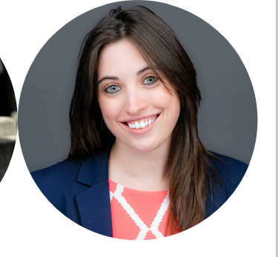

**Dr. Alyssa Marsico (She/Her/Hers)**

I received my Forensic Science and Chemistry Bachelor’s Degrees with a minor in Math from the University of New Haven. While there, I tutored in the CLR as a student tutor. Once I graduated, I went on to the University of Massachusetts in Amherst and earned my PhD in Analytical Chemistry. I now teach Forensic Science here at the University. My hobbies include spending time with my dogs, video games, hunting, fishing, disc golf, working out, off-roading, working on my truck, reading, playing guitar, and anything else to do outdoors!

**Tutors:** BIOL-1121, BIOL-1122, BIOL-1123, BIOL-1124, BIOL-2253, BIOL-2254, BIOL-2255, BIOL-2256, BIOL-2259, BIOL-2261, BIOL-2262, BIOL-3393, BIOL-4461, BIOL-4462, BIOL-4493, BIOL-4501, CHEM-1105, CHEM-1106, CHEM-1115, CHEM-1116, CHEM-1117, CHEM-1118, CHEM-2201, CHEM-2202, CHEM-2203, CHEM-2204, CHEM-2211, CHEM-2222, CHEM-3331, CHEM-3332, CHEM-3333, CHEM-3334, CHEM-3341, CHEM-4411, CHEM-4501, CJST-1100, CJST-2250, EASC-1120, FORS-2204, FORS-2215, FORS-2216, FORS-2217, FORS-2227, FORS-2250, FORS-3325, FORS-3402, FORS-4403, FORS-4404, FORS-4415, FORS-4416, FORS-6612, FORS-6613, FORS-6620, FORS-6621, FORS-6640, FORS-6641, FORS-6662, FORS-6698, MATH-1103, MATH-1104, MATH-1108, MATH-1110, MATH-1115, MATH-1117, MATH-1118, PHYS-1100, PHYS-1103, PHYS-1104, PHYS-1111, PHYS-1113, PHYS-1114, PHYS-1116, PHYS-1130 PHYS-1131, PHYS-1150, PHYS-1151

**Link:** <http://newhaven.campus.eab.com/pal/u2rtA9HU2k>

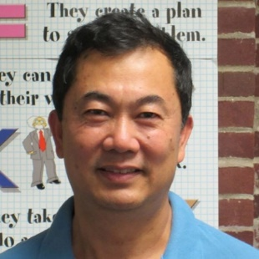

**Dr. Kevin Lin (He/Him/His)**

I hold a PhD in Synthetic Chemistry. I work as a medicinal chemist and an adjunct professor in organic chemistry labs. As a professional tutor, I am here to help with all chemistry courses from undergraduate to graduate and mathematics I/II.

**Tutors:** BIOL-2261, BIOL-4461, BIOL-4462, CHEM-1105, CHEM-1106, CHEM-1115, CHEM-1116, CHEM-1117, CHEM-1118, CHEM-2201, CHEM-2202, CHEM-2203, CHEM-2204, CHEM-2211, CHEM-2212, CHEM-2221, CHEM-2222, CHEM-3331, CHEM-3332, CHEM-3333, CHEM-3341, CHEM-4411, CHEM-6615, CHEM-6631, CHIN-1101, CHIN-1102, CHIN-3301, MATH-1103, MATH-1104, MATH-1108, MATH-1110, MATH-1115, MATH-1117, MATH-1118, MATH-1121, MATH-2203

**Link:** <http://newhaven.campus.eab.com/pal/eEPs_mmiQX>

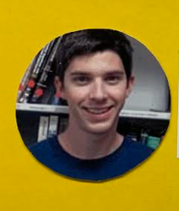

**Rob Harvey (He/Him/His)**

I am a lecturer in the Chemistry Department. I have been tutoring since 2009. When the weather is nice, you can find me hiking, biking, or kayaking around CT. If not, you’ll find me inside watching Netflix and solving Rubix Cubes.

**Tutors:** CHEM-1100, CHEM-1105, CHEM-1106, CHEM-1111, CHEM-1115, CHEM-1116, CHEM-1117, CHEM-1118, CHEM-2201, CHEM-2202, CHEM-2203, CHEM-2204, CHEM-2211, CHEM-2212, CHEM-2221, CHEM-2222, CHEM-3331, CHEM-3332, CHEM-3333, CHEM-3334, COOP-7701, FORS-2215, FORS-2216, FORS-2217, FORS-3402, FORS-4403, FORS-4404, FORS-4415, MATH-1017, MATH-1103, MATH-1104, MATH-1108, MATH-1110, MATH-1115, MATH-1117, MATH-1118, MATH-1121, PHYS-1100, PHYS-1103, PHYS-1104, PHYS-1111, PHYS-1113, PHYS-1114, PHYS-1116, PHYS-1130, PHYS-1131, PHYS-1150, PHYS-1151

**Link:** <http://newhaven.campus.eab.com/pal/ca_7E2P1tE>

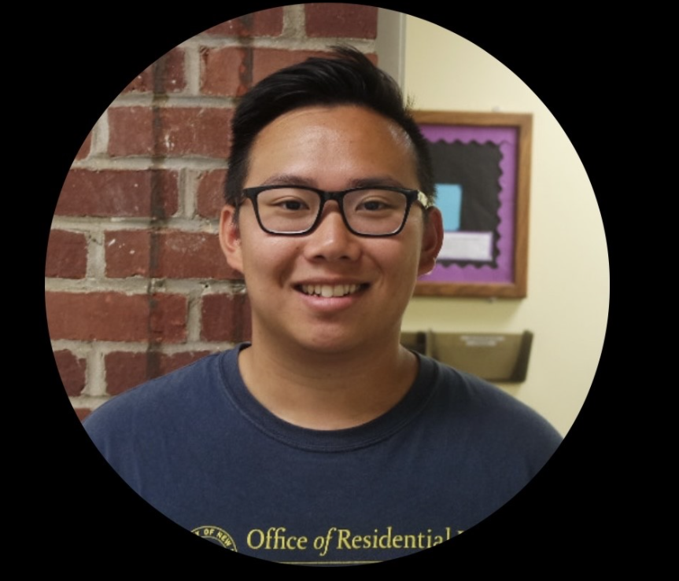

**Thomas Hong (He/Him/His)**

I have a Bachelor degrees in Forensic Science and Chemical Engineering as well as a Masters in Chemistry. During my free time, I enjoy playing tennis. I tutor chemistry, engineering, math, and physics.

**Tutors:** BIOL-2261, BIOL-4461, BIOM-6610, CHEM-1100, CHEM-1106, CHEM-1111, CHEM-1115, CHEM-1116, CHEM-1117, CHEM-1118, CHEM-2201, CHEM-2202, CHEM-2203, CHEM-2204, CHEM-2211, CHEM-2212, CHEM-3331, CHEM-3332, CHEM-3333, CHEM-3334, CHEM-6607, CHEM-6615, CHEM-6682 CHME-2220, CHME-3311, CHME-3315, CHME-3316, CHME-3321, CHME-3362, CHME-4401, CHME-4415, CHME-4461, CHME-4462, CHME-4497, CHME-4498, EASC-1101, EASC-1102, EASC-1107, EASC-1109, EASC-1112, EASC-1120, EASC-1121, EASC-2211, EASC-2213, EASC-2224, EASC-2232, PHYS-1100, PHYS-1103, PHYS-1104, PHYS-1111, PHYS-1113, PHYS-1114, PHYS-1130, PHYS-1131, PHYS-1150, PHYS-1151

**Link:** <http://newhaven.campus.eab.com/pal/D15NljbUSo>

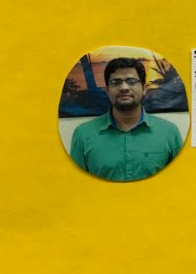

**Syed Ravzi (He/Him/His)**

I have been a professional tutor at the CLR since Fall 2016. I graduated from UNH with a Bachelor’s and Master’s in Electrical Engineering. In my spare time, I am a Nouha Khwan (one who recites prayers).

**Tutors:** CHEM-1111, CHEM-1115, EASC-1107, EASC-1109, EASC-1112, EASC-2211, EASC-2230, EASC-2232, ELEC-1155, ELEC-2235, ELEC-2247, ELEC-3302, ELEC-6637, MATH-1017, MATH-1103, MATH-1108, MATH-1110, MATH-1115, MATH-1117, MATH-1118, MATH-2203, MATH-2204, MATH-4450, PHYS-1100, PHYS-1103, PHYS-1104, PHYS-1111, PHYS-1113, PHYS-1114, PHYS-1150, PHYS-1151, PHYS-2205, PHYS-2206

**Link:** <http://newhaven.campus.eab.com/pal/kFjR4kyAAR>

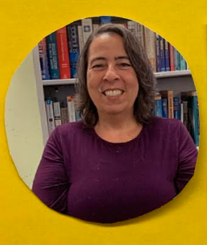

**Susan DeLeonardo**

I hold a Master’s degrees in Geophysics and Archaeology and a Bachelor’s degree in Geological Science. I teach Physics at UNH, Earth Science at Quinnipiac University, and am a lifelong Math and Science tutor. Outside the classroom, I teach swimming, music, and play drums in a band.

**Tutors:** CHEM-1100, CHEM-1111, CHEM-1115, CHEM-1116, MATH-1017, MATH-1115, MATH-1117, MATH-1118, PHYS-1100, PHYS-1104, PHYS-1111, PHYS-1113, PHYS-1114, PHYS-1116, PHYS-1130, PHYS-1131, PHYS-1150, PHYS-1151, PHYS-2203, PHYS-2204, PHYS-2205, PHYS-2206

**Link:** <http://newhaven.campus.eab.com/pal/sK8IwAG2E->

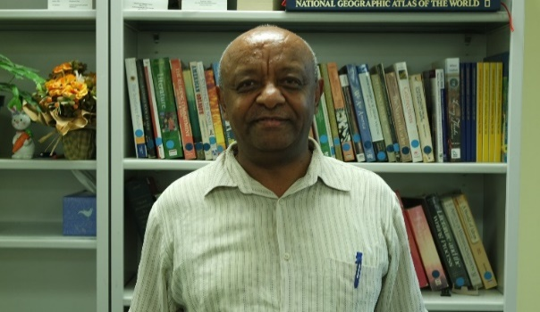

**Alem Lemma (He/Him/His)**

Hello, I am Dr. Lemma and I hold MA degrees in Economic Policy Making, Economics and International Development and a PhD in Development Economics and Applied Econometrics. I tutor math, quantitative analysis, and statistics.

**Tutors:** CJST-2251, ECON-1133, ECON-1134, ECON-3342, ECON-6633, FINC-1123, MATH-1103, MATH-1104, MATH-1108, MATH-1110, MATH-1115, MATH-1117, MATH-1118, MATH-1121, MATH-2228, QANL-3380

**Link:** [**http://newhaven.campus.eab.com/pal/ohdNOa8i9k**](http://newhaven.campus.eab.com/pal/ohdNOa8i9k)

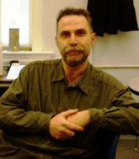

**Nicolas Zoghb (He/Him/His)**

I have been with the CLR since 1988. I hold a BS and an MA in Electrical Engineering and a BS in Applied Mathematics. I tutor math and physics courses at UNH.

**Tutors:** MATH-1103, MATH-1104, MATH-1108, MATH-1110, MATH-1115, MATH-1117, MATH-1118, MATH-1121, MATH-1166, MATH-2203, MATH-2204, MATH-3310, MATH-3311, MATH-3321, MATH-3338, MATH-3371, MATH-4472, MATH-4492, PHYS-1100, PHYS-1103, PHYS-1104, PHYS-1111, PHYS-1116, PHYS-1130, PHYS-1131, PHYS-1150, PHYS-1151, PHYS-2203, PHYS-2204, PHYS-2205, PHYS-2206

**Link:** <http://newhaven.campus.eab.com/pal/eMii6kzU1a>