University of New Haven

Center for Learning Resources

Paramedicine

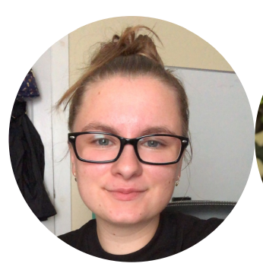

**Brandi Babcock (She/Her/Hers)**

Hello, my name is Brandi and I am the paramedicine tutor here at UNH. I tutor at Yale Sponsor Hospital and at One Care Lane and hope to see you soon!

**Tutors:** HLTH-2200, PARA-1141, PARA-1175, PARA-2231, PARA-2236, PARA-2237, PARA-2238, PARA-2239, PARA-2275, PARA-3331

**Link:** <http://newhaven.campus.eab.com/pal/jPaUCMk6kb>