University of New Haven
Center for Learning Resources
Statistics and Quantitative Analysis Tutors

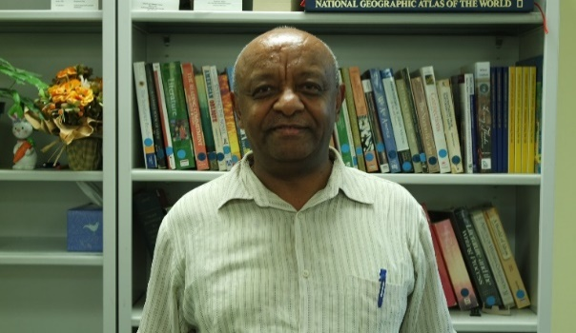
Alem Lemma (He/Him/His)
Hello, I am Dr. Lemma and I hold MA degrees in Economic Policy Making, Economics and International Development and a PhD in Development Economics and Applied Econometrics. I tutor math, quantitative analysis, and statistics.
Tutors: CJST-2251, ECON-1133, ECON-1134, ECON-3342, ECON-6633, FINC-1123, MATH-1103, MATH-1104, MATH-1108, MATH-1110, MATH-1115, MATH-1117, MATH-1118, MATH-1121, MATH-2228, QANL-3380
Link: http://newhaven.campus.eab.com/pal/ohdNOa8i9k
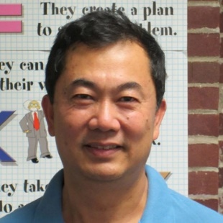
Dr. Kevin Lin (He/Him/His)
I hold a PhD in Synthetic Chemistry. I work as a medicinal chemist and an adjunct professor in organic chemistry labs. As a professional tutor, I am here to help with all chemistry courses from undergraduate to graduate and mathematics I/II.
Tutors: BIOL-2261, BIOL-4461, BIOL-4462, CHEM-1105, CHEM-1106, CHEM-1115, CHEM-1116, CHEM-1117, CHEM-1118, CHEM-2201, CHEM-2202, CHEM-2203, CHEM-2204, CHEM-2211, CHEM-2212, CHEM-2221, CHEM-2222, CHEM-3331, CHEM-3332, CHEM-3333, CHEM-3341, CHEM-4411, CHEM-6615, CHEM-6631, CHIN-1101, CHIN-1102, CHIN-3301, MATH-1103, MATH-1104, MATH-1108, MATH-1110, MATH-1115, MATH-1117, MATH-1118, MATH-1121, MATH-2203
Link: http://newhaven.campus.eab.com/pal/eEPs_mmiQX
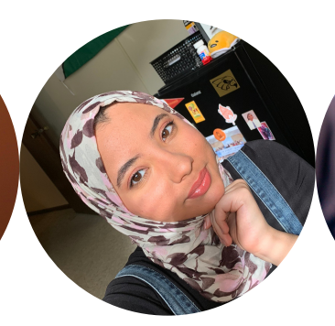
Luzan JadKarim (She/Her/Hers)
My name is Lu and I'm a current MPH student. I've previously tutored Biology, Psychology, and Chemistry at my undergrad institution. Currently, I'm tutoring Public Health courses. My hobbies include watching anime, baking, gaming, and working out!
Tutors: PUBH-6600, PUBH-6615, PUBH-6625, PUBH-6645, PUBH-6655, PUBH-6660, PUBH-6672
Link: http://newhaven.campus.eab.com/pal/RdEkErymG6

