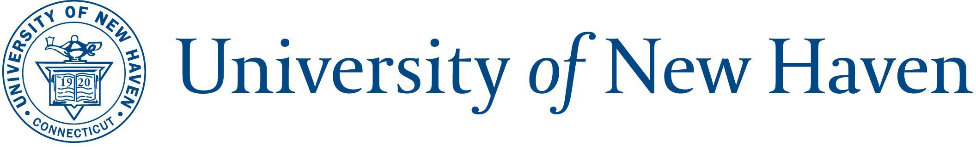

2026 Holiday Calendar

|  |  |
| --- | --- |
| Day | Date Observed |
| **New Year’s Day** | Thursday, January 1, 2026 |
| **Martin Luther King Jr. Day** | Monday, January 19, 2026 |
| **Presidents’ Day** | Monday, February 16, 2026 |
| **Memorial Day** | Monday, May 25, 2026 |
| **Juneteenth** | Friday, June 19, 2026 |
| **Independence Day** | Friday, July 3, 2026 |
| **Labor Day** | Monday, September 7, 2026 |
| **½ Day Before Thanksgiving** | Wednesday, November 25, 2026 |
| **Thanksgiving Day** | Thursday, November 26, 2026 |
| **Day After Thanksgiving** | Friday, November 27, 2026 |
| **½ Day Christmas Eve (observed)** | Thursday, December 24, 2026 |
| **Christmas (observed)** | Friday, December 26, 2026 |
| **Winter Recess** | Monday, December 28, 2026  Tuesday, December 29, 2026  Wednesday, December 30, 2026  Thursday, December 31, 2026 |
|  | |

***Holidays for union employees will be coordinated in conjunction with the employees’ respective collective bargaining agreement and specific procedural guidelines for essential departments.***

The university’s holiday policy may be found on mycharger.newhaven.edu. All policies, procedures and/or guidelines described herein may be modified or discontinued at any time, for any reason at the University’s full and sole discretion. No policy, procedure and/or guideline should be construed as a contract or term or condition of employment between an employee and the University. This policy/procedure is not intended to alter or modify any of the terms of any collective bargaining agreement or the Faculty Handbook.